11/5 Meeting
Date: 11/5/25
Time: 11:00am-12:00pm CDT
Attendees: Juliette Reeder, Jack Hicks, Forrest Tuschhoff, Dr. Chuck Bunting, Dr. Pavithrakrishnan Radhakrishnan

Predicted LPDA (Log-Periodic Dipole Antenna) Behavior:
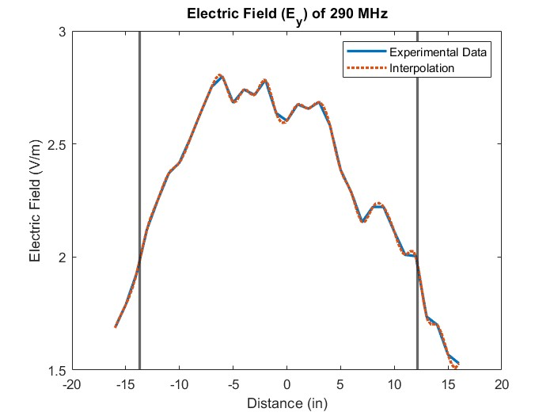
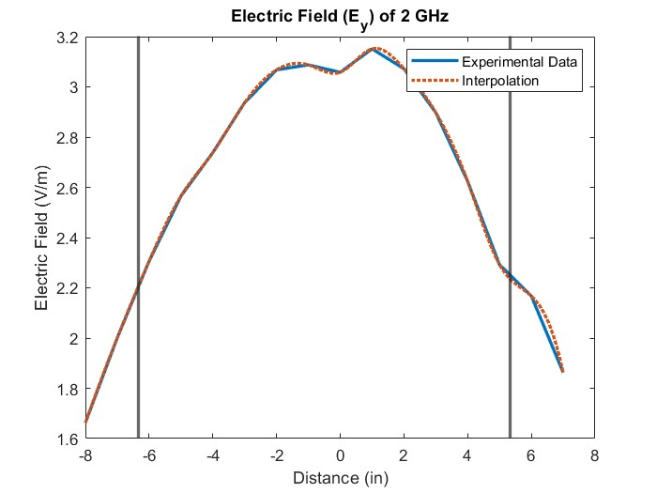
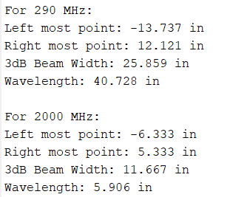

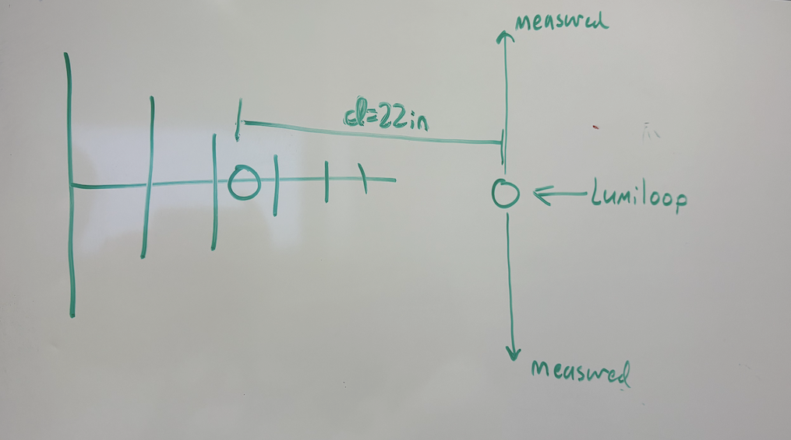
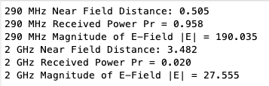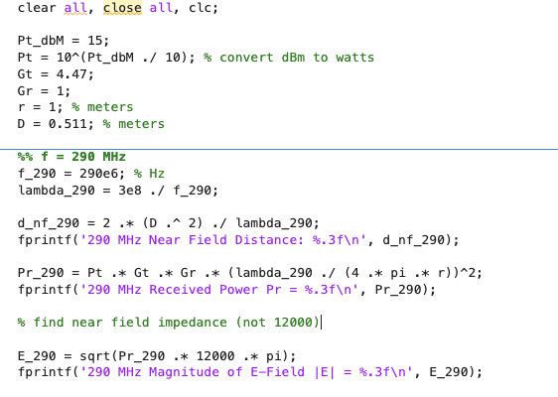

Lumiloop modes:
- Mode 0 for lower frequencies (see manual)
- Mode that encompasses range of frequencies being measured
- 3 GHz -> mode 2 or 3 (see manual)
- 3/6 axes activated depending on mode
- See lumiloop recommendations for mode choice
- Stick with 0, 1, 2 depending on application

Specify what frequency is being used in Lumiloop
- Make sure lumiloop setting and transmit frequency match
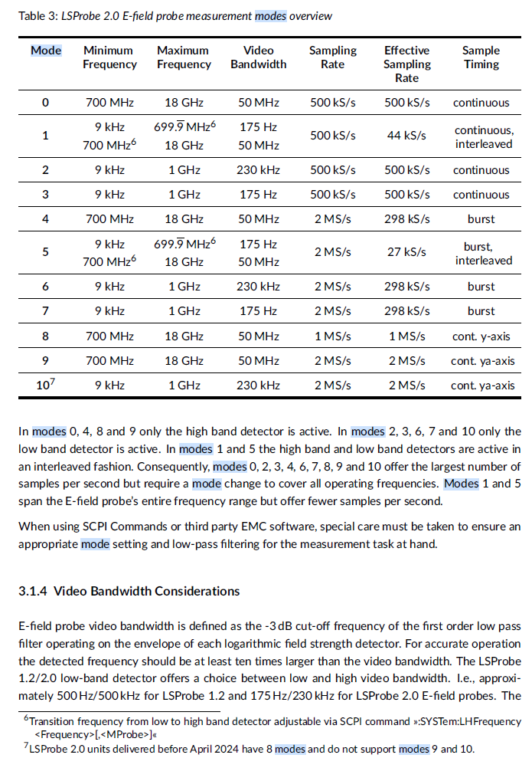

Antenna assembly status:
Boom complete
All elements assembled
Issues encountered:
- Power supply to signal generator
  - Spec out lithium ion battery (​HorizontalHFPowerBudget​)
  - Gas powered generator
  - Long extension cord
- Extremely rocky soil west of REFTAS
  - Build elsewhere
  - Cinderblocks/sandbags (not enough tension)
  - Hammer drill with masonry drill bit
- Wire (non-insulated)
  - Invest in insulated stranded 18 gauge wire
  - Cut new lengths and attach, time permitting
  - Suggest for future renditions
- Guy wires for support beams
  - ⅓ up height of support
  - Shorten rope to ~6ft

Future measurements:
- Small LPDA proportionally close to ground
- Large LPDA

